Learning from Data
Practical Session 2: Linear Regressions

Part A
Please run the code below in your Python programming environment. I recommend running it on a Jupyter notebook, with every few lines of code in a different cell within the notebook.

- Load the file cars_dataset.csv using the python pandas library:
import pandas as pd
cars = pd.read_csv('cars_dataset.csv')
- If you want to display the variable you have just created, cars.head() will show its first 5 rows. You can run it with cars.head() or display(cars.head()).

- Make a scatterplot for the weight and the horsepower columns (see Figure 1, left).
Hint: https://pandas.pydata.org/docs/reference/api/pandas.DataFrame.plot.scatter.html

- Create two variables, X and y, from the weight and horsepower columns, by doing:
x = cars[['weight']]
y_data = cars['horsepower']
- Import the LinearRegression function, and fit a linear regression to predict y from X.
- Print out the slope coefficient and the intercept using the print() function.

- Make a new variable, y_pred, and assign it the predicted values.
- Assign y_pred to a new column in the dataset:
cars['predicted_horsepower'] = y_pred

- Visualize the regression by plotting the actual values and the calculated values (see Figure 1, right).
Hint:
https://pandas.pydata.org/pandas-docs/stable/reference/api/pandas.DataFrame.plot.line.html
ax = cars.plot.scatter(x='weight', y='horsepower')
ax = cars.plot.line(x='weight', y='predicted_horsepower', ax=ax, c='red')
- Calculate R² and print its value.
Hint: most of the code you will use his available in the link below.
https://scikit-learn.org/stable/modules/generated/sklearn.linear_model.LinearRegression.html
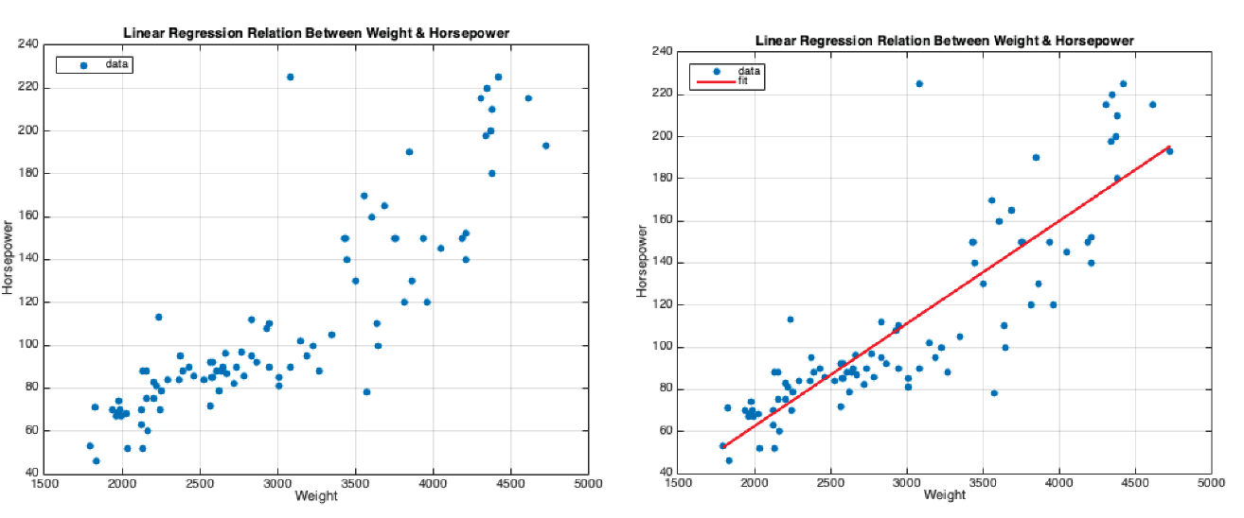
Figure 1: Expected output of Part A.

Part B

- Considering the same dataset, but a different pair of columns, repeat the steps in Part A to calculate the linear regression between a car’s weight and its miles-per-galon (MPG) value.

- Expected output:
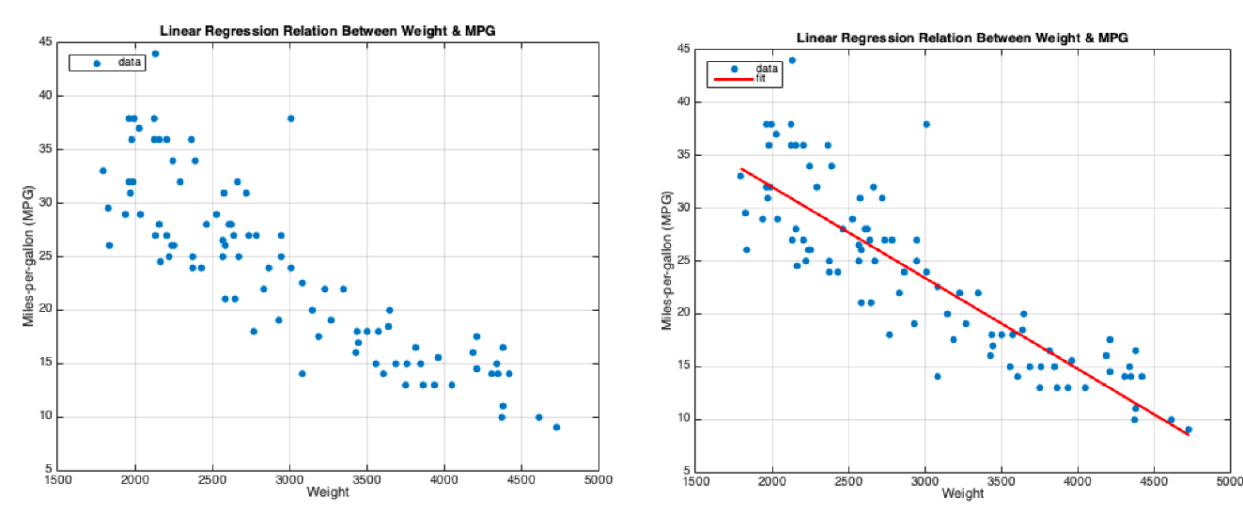
Figure 2: Expected output of Part B.

Part C
In this part, we will train the linear regression with part of the data, and test it on another part.

- Split the data into training/testing sets, 70% for training and 30% for testing. This can be done by:
X_train, X_test, y_train, y_test = train_test_split(x, y, test_size=0.30)
- Train the model using X_train and y_train and compute the linear regression coefficients.
- Use X_test and y_test to calculate R². Print its value.
- Predict the values for y based on X_test. Store that prediction in a new variable y_pred.
- Make a copy of X_test, and add one column with y_test, and another with y_pred.
- Make a scatter plot showing X_test vs. y_test, along with a line plot X_test vs. y_pred(see Figure 3)

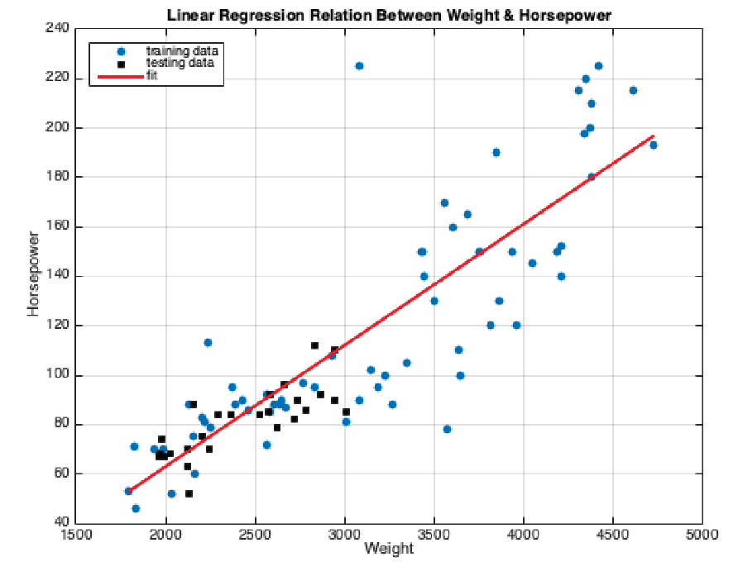
Figure 3: Expected output of Part C.

